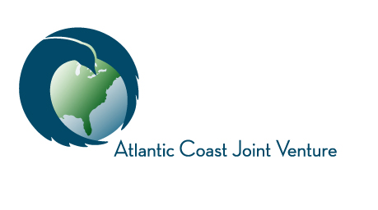

Funding Acceptance Policy Addendum: Approved:
Corporate Funding Support Template Language

The ACJV Management Board will accept corporate donations and contributions that support the work of the ACJV partnership in accordance with our Funding Acceptance Policy. We propose that the following template language be used by corporate partners to acknowledge their support of the ACJV on external communications:

The corporation name supports the Atlantic Coast Joint Venture, a partnership of state and federal agencies and non-profit organizations partnering to restore and sustain native bird populations and habitats in the Atlantic Flyway of the United States, from Maine to Puerto Rico. The Atlantic Coast Joint Venture Management Board is comprised of representatives of Maine Department of Inland Fisheries and Wildlife, New Hampshire Fish & Game, Vermont Fish & Wildlife Department, Massachusetts Division of Fisheries and Wildlife, Rhode Island Division of Fish & Wildlife, Connecticut Department of Energy and Environmental Protection, New York Department of Environmental Conservation, Pennsylvania Game Commission, New Jersey Division of Fish and Wildlife, Delaware Division of Fish and Wildlife, Maryland Department of Natural Resources, Virginia Department of Game and Inland Fisheries, North Carolina Wildlife Resources Commission, South Carolina Department of Natural Resources, Georgia Department of Natural Resources, Florida Fish and Wildlife Conservation Commission, Puerto Rico Departamento de Recursos Naturales y Ambientales, National Park Service, US Fish and Wildlife Service, USDA Forest Service, USDA Natural Resources Conservation Service, US Geological Survey, American Bird Conservancy, Ducks Unlimited, National Audubon Society, National Fish and Wildlife Foundation, and The Nature Conservancy.

Resolution:
On October 4, 2016, the Atlantic Coast Joint Venture Management Board herby approves this Funding Acceptance Policy Addendum.

_______________________________________________
Breck Carmichael, Board Chair

