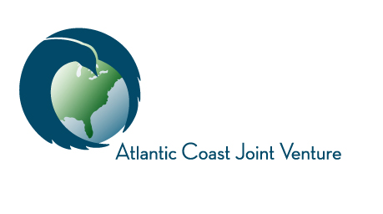

Funding Acceptance Policy Approved:
This policy, as adopted by the Atlantic Coast Joint Venture (ACJV) Management Board, describes the Funding Acceptance Policy for outside contributions in support of ACJV activities. The ACJV partnership welcomes contributions (financial and in-kind) from partners to support programs, priorities and tasks identified by the Management Board, as described in our Strategic Plan, Biological Priorities document, and/or bi-annual staff Work Plan. Potential financial supporters include, but are not limited to corporate, federal, state, NGO and private entities. We will work with partners to secure contributions to support work performed under the ACJV Partnership and will provide accountability and reporting for contributed funds. However, we will not divert staff time, energy or resources to activities requested by a partner – even if fully funded – beyond the scope of what is identified in the aforementioned guiding documents.
This acceptance policy applies to all contributing partners according to the following terms:
- First-time corporate contributors must be reviewed and approved by the ACJV Management Board before contributions will be accepted and then periodically reviewed thereafter;
- Any affiliation with or use of the ACJV name or logo by corporate contributors must be approved by the ACJV Management Board;
- All contributions in excess of $25,000, regardless of origin (corporate, federal, state, NGO, private, etc.), will be reviewed by the Management Board prior to acceptance. Grant funds acquired through a competitive grant process are exempt from this requirement;
- The ACJV Management Board may choose not to accept contributions from any entity if it deems that doing so would damage the integrity, impartiality, or public confidence of the ACJV partnership;
- The ACJV will not provide any goods or services in exchange for contributions in support of the Joint Venture
Resolution:
On October 4, 2016, the Atlantic Coast Joint Venture Management Board herby approves this Funding Acceptance Policy.
_______________________________________________
Breck Carmichael, Board Chair

