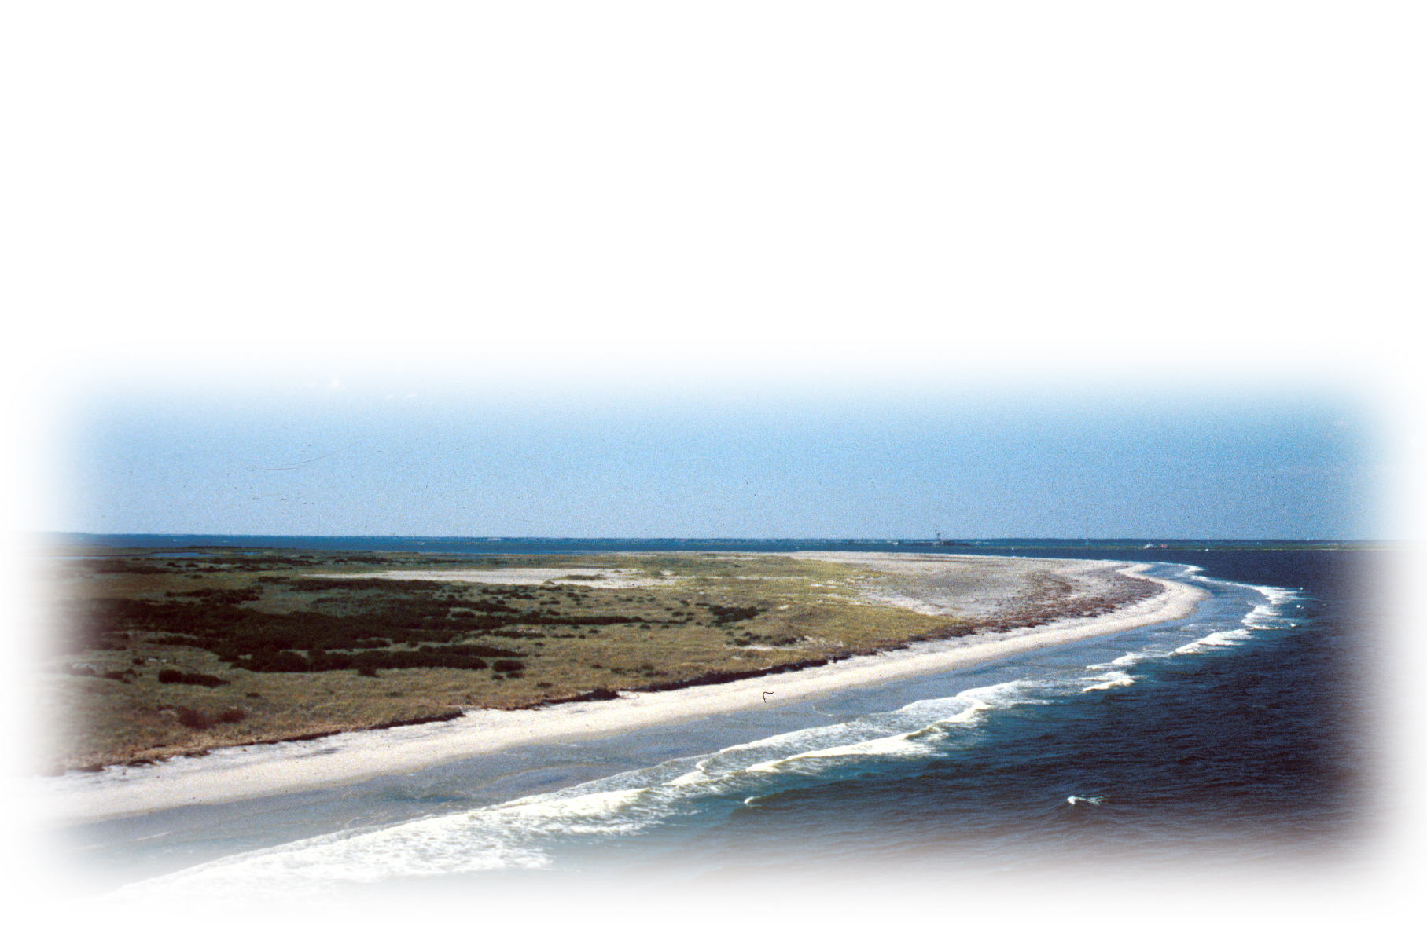
ATLANTIC COAST JOINT VENTURE

Peninsular Florida Bird Conservation Initiative

he northern portion of Peninsular Florida is a transitional zone where the pine and bottomland hardwood elements of the Coastal Plain begin to merge with the tropical elements of south Florida. Many of the important pine and bottomland birds of the Coastal Plain, including Red-cockaded Woodpecker and Swallow-tailed Kite, extend into this area. The central scrub-oak Lake Wales Ridge is a center of endemism that includes all of the world’s Florida Scrub-Jays. Farther south, in the subtropical zone of the state, a normally frost-free climate creates conditions for mangroves, everglades, and tropical hammocks, tying this area more closely to the Bahamas and Caribbean than to the rest of the United States. Snail Kite, Short-tailed Hawk, and Limpkin breed in interior wetlands, with Mangrove Cuckoo and Black-whiskered Vireo in coastal mangroves. One of the greatest wading-bird concentrations in the world is in the Everglades. Wintering waterfowl abound in coastal waters, including large numbers of Lesser Scaup, Ring-necked Duck, and Green-winged Teal. The endemic Florida subspecies of Mottled Duck, Wood Duck, and Fulvous Whistling-Duck also breed in the area. Most of the remaining nesting Snowy Plovers in the Southeast occur along Florida’s Gulf Coast. Extraordinary numbers of wintering and intransit shorebirds also use the region, particularly Short-billed Dowitchers, but also Piping Plover, Dunlin, and Red Knot.

T

-lies entirely within the Atlantic Coast Joint Venture and the state of Florida

-one of the most important geographic areas on the Atlantic Coast

-fits well with protection and restoration of the Everglades ecosystem

-continued threats are increasing human population growth, pollution, intensive
agriculture, and water quality

-about 54% of subtropical Florida in public ownership, private lands are key to bird conservation

-coordination on issues effecting habitat and bird populations through the State of Florida proper are tremendous, particularly with the Comprehensive Everglades Restoration Plan effort (CERP), which encompasses the entire Kissimmee River watershed south into Florida Bay and the Florida Keys.

In 2007, the Florida Bird Conservation Initiative (FBCI) was established, facilitated by the Florida Fish & Wildlife Conservation Commission, the Atlantic Coast Joint Venture, and a wide variety of conservation partners in the State of Florida. The FBCI will address bird conservation over the entire state, including two Joint Ventures and two Bird Conservation Regions (27 and 31). The FBCI was formed as a voluntary public-private partnership that seeks to promote the sustainability of native Florida birds and their habitats through coordinated efforts. Goals and additional information on the FBCI can be found at: http://myfwc.com/FBCI/FBCI_index.htm#

For more information contact: Elena Sachs Craig Watson
Bird Conservation Initiative Coordinator Atlantic Coast Joint Venture
Florida Fish & Wildlife Conservation Commission 176 Croghan Spur Rd., Suite 200
1239 SW 10th St. Charleston, SC 29407
Ocala, FL 34471 843.727.4707, ext. 304
352.732.1225 craig_watson@fws.gov
Elena.Sachs@myfwc.com

PENINSULAR FLORIDA BIRD CONSERVATION REGION

PARTNERS
http://myfwc.com/FBCI/FBCI_partners.htm
Over 21 conservation organizations, including state, federal, non-governmental
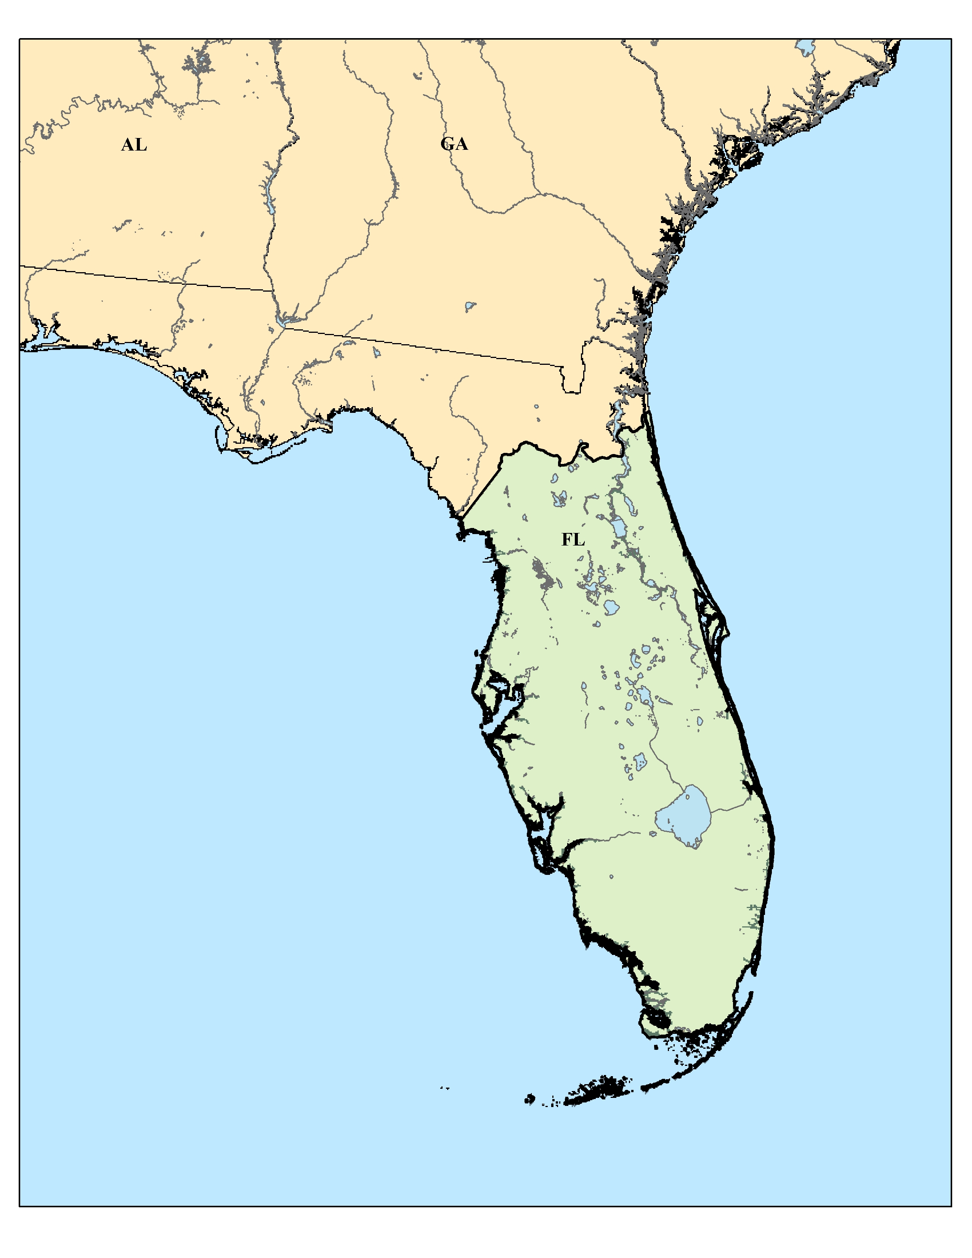
organizations, and academic institutions comprise the major partners forming the FBCI.

