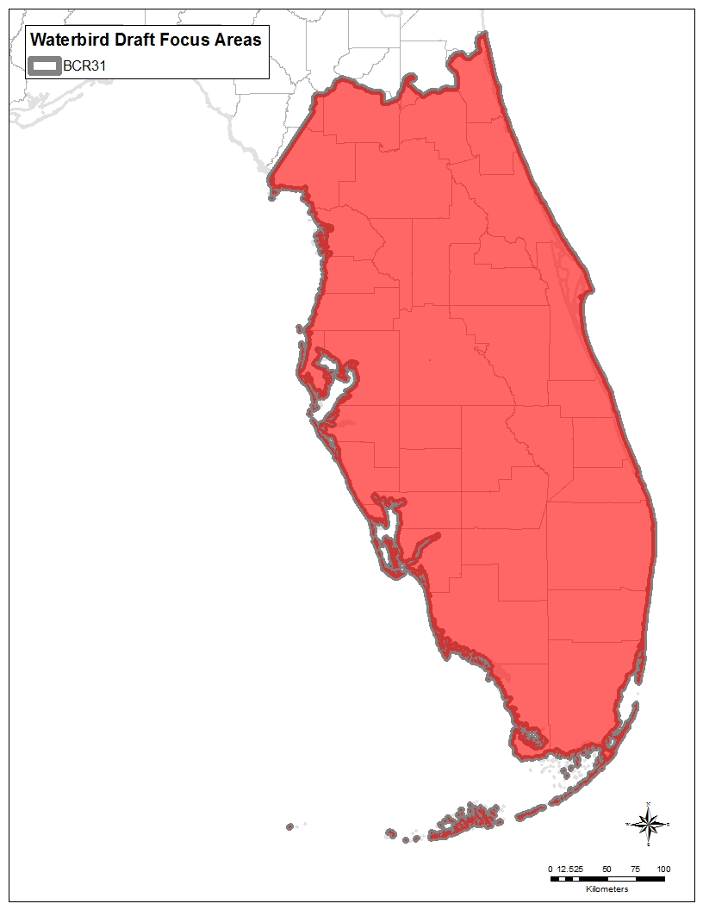
Figure 1. Waterbird focus areas.

After many attempts to narrow down waterbird habitat in the state to the most important areas for waterbirds, it become apparent that no single approach resulted in a satisfactory configuration of focus areas. Focus Areas were first created based on FWC’s wading bird foraging habitat model because it was assumed that wading bird habitat would also be important for other waterbirds. Starting with the wading bird foraging habitat map, 5- and 10-km (3.1 and 6.2-mile) aggregations were used to form larger polygons (Figure 2). The resulting map showed all but a small area of the peninsula (e.g., southeastern Florida, the Brooksville Ridge area) as important to wading birds. Next, a map using buffers around wading bird and Wood Stork nesting colonies was created. This map showed an even smaller percent of the state not covered by priority habitat (Figure 3). For Wood Stork colonies, a buffer of 24.1 km (15 miles) was used. Fifteen miles is an average buffer size between the USFWS 20.9-, 24.1-, and 29.9-km (13-, 15-, and 18.6-mile) buffers recommended for different parts of the state (USFWS 2016). For wading birds, a 12.9-km (8-mile) radius was used. Eight miles is in between the 11.3- to 14.5-km (7- to 9-mile) radius suggested as a foraging habitat area in FWC’s wading bird action plan (FWC 2013c).
As can be seen from Figures 6 and 7, only a very small percentage of the BCR (mostly the center of Lake Okeechobee) would be left off a map using a combination of these two methods to identify focus areas. For this reason, the entire BCR is considered a focus area for waterbirds.

5-km aggregation | 10-km aggregation
Figure 2. FWC wading bird habitat mapped to 5- and 10-km (3.1 and 6.2-mile) aggregations.
Source: FWC 2013c; maps by Amanda Kubes, FWC

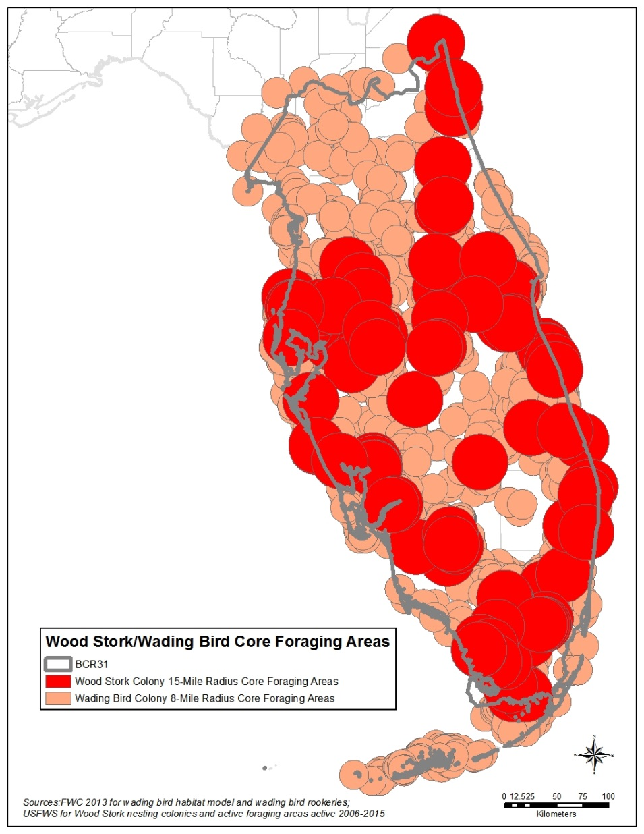
Figure 3. Wood Stork and wading bird colony buffers.
Source: FWC 2013c; USFWS 2016

Seabird Focus Areas
Seabird focus areas are based on Least Tern and Black Skimmer habitat models in FWC’s beach-nesting bird action plan (FWC 2013a) because these two species encompass the needs of a majority of focal seabirds. These areas cover the majority of the peninsular Florida coast with the exception of southwest Florida, much of which is dominated by mangroves. While at any one point in time this entire area is not important to seabirds, nesting areas frequently shift with changing habitat conditions, and this broad coverage allows potential new nesting areas to be captured. A broad belt across the interior of the peninsula has been used by nesting Least Terns and could be important depending on local variable conditions. Other sources for seabird focal areas include the following:
- Dry Tortugas due to the particular importance of these islands for seabirds with otherwise very limited breeding ranges in the United States (e.g., Magnificent Frigatebird, Masked and Brown Booby, Brown Noddy, and Sooty Tern).
- The area around Cedar Key for nesting Least Terns and for nonbreeding Black Skimmers with flocks of hundreds regularly wintering in the area (J. Brush, FWC Wildlife Biologist, pers. comm.; eBird 2016).

A seabirds focus areas map was created separate from the waterbirds map because of the importance of Florida for seabirds and the differences in habitat between seabirds and other waterbirds.

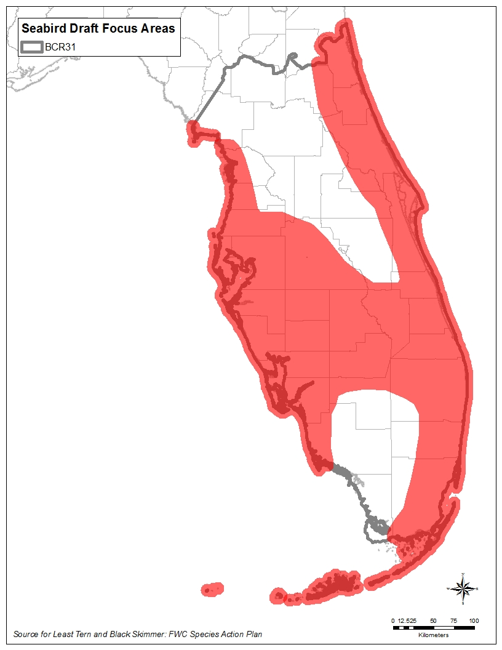
Figure 4. Seabird focus areas.
Source: FWC 2013a

Shorebird Focus Areas
Shorebird focus areas are based on Snowy Plover and American Oystercatcher maps in FWC’s beach-nesting bird action plan (FWC 2013a) because these two species encompass the needs of a majority of focal shorebirds. This focus area covers the majority of both coasts because of the uncertainty in the location of shorebird nesting and foraging areas. Other sources for shorebird focal areas include the following:
- Piping Plover Critical Habitat (USFWS 2001)
- Bahia Honda and Long Key in the Florida Keys (J. Duquesnel, FDEP and Keys Shorebird Partnership Coordinator, pers. comm.)
- Crandon Park for value for wintering Piping Plovers (although not critical habitat, these beaches regularly attract 30 nonbreeding Piping Plovers [eBird 2016])
- Coast between and including Lake Ingraham and Snake Bight and nearby lagoons due to the importance for wintering shorebirds (N. Douglass, FWC Wildlife Biologist, pers. comm.)
- Lake Okeechobee and agricultural areas to the southeast for their importance for migrant shorebirds (N. Douglass and R. Zambrano, FWC Wildlife Biologists, pers. comm.; eBird 2016).

While many interior parts of the state are important for migrating and wintering shorebirds (e.g., agricultural areas), this plan has chosen to focus primarily on coastal shorebird habitat, with the exception of the Everglades Agricultural Area and the Lake Okeechobee shoreline, a part of the state with very high concentrations of shorebirds in migration.

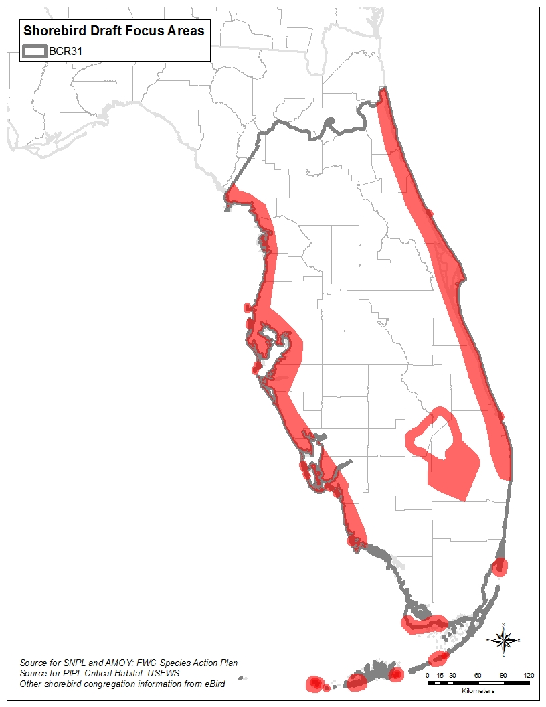
Figure 5. Shorebird focus areas.
Source: FWC 2013a; USFWS 2001, eBird 2016

Landbird Focus Areas
With a wide variety of priority species of landbirds, including many that also use aquatic habitats, a landbird focus area that includes only uplands would not meet all species’ needs. Landbird needs are better met by using Critical Lands and Waters Identification Project (CLIP) Biodiversity Resource Priorities 1 and 2 (Oetting, Hoctor, and Volk 2014) because these areas take into account the state’s most important areas for Strategic Habitat Conservation, Vertebrate Potential Habitat Richness, Rare Species Habitat Conservation, and Priority Natural Communities. The CLIP priorities map (Figure 6) was simplified by tracing the outlines of the major aggregations of CLIP Priority 1 and 2 lands to form larger polygons so that it is useful at the scale of an standard US letter size (8.5 by 11-inch [21.6 by 27.9-cm]) page.

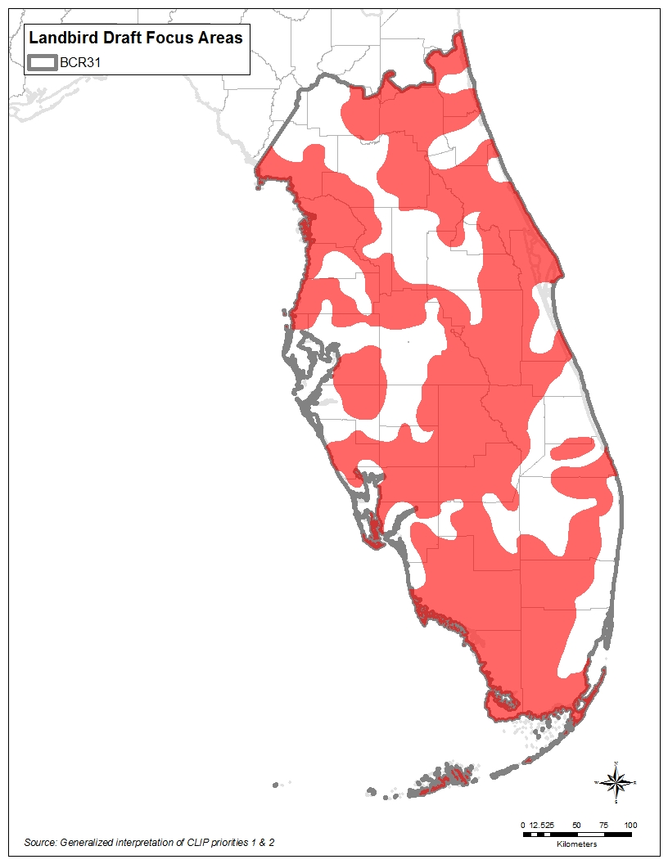
Figure 6. Landbird focus areas.
Adapted from: Oetting, Hoctor, and Volk 2014

