Appendix F. BCR 14 Habitat Focus Area maps and data sheets.
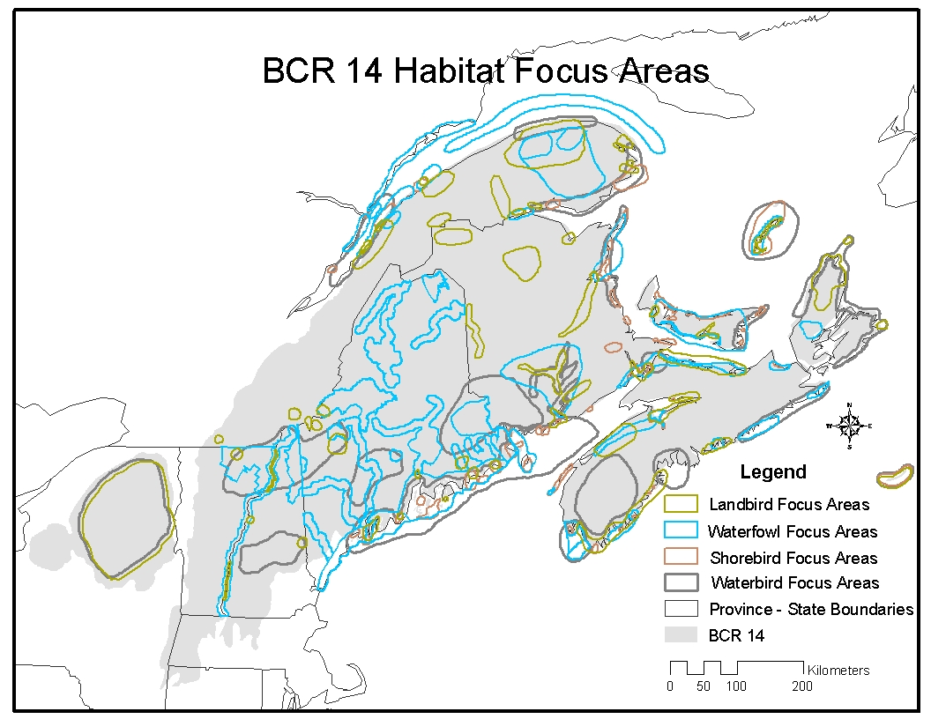
Fig. 8. Map of all habitat focus areas in BCR 14, illustrating areas of overlap among focus areas for two or more taxonomic groups. For more details, see Waterbird Focus Areas, Landbird Focus Areas, Waterfowl Focus Areas, and Shorebird Focus Areas.

Waterbird Focus Areas

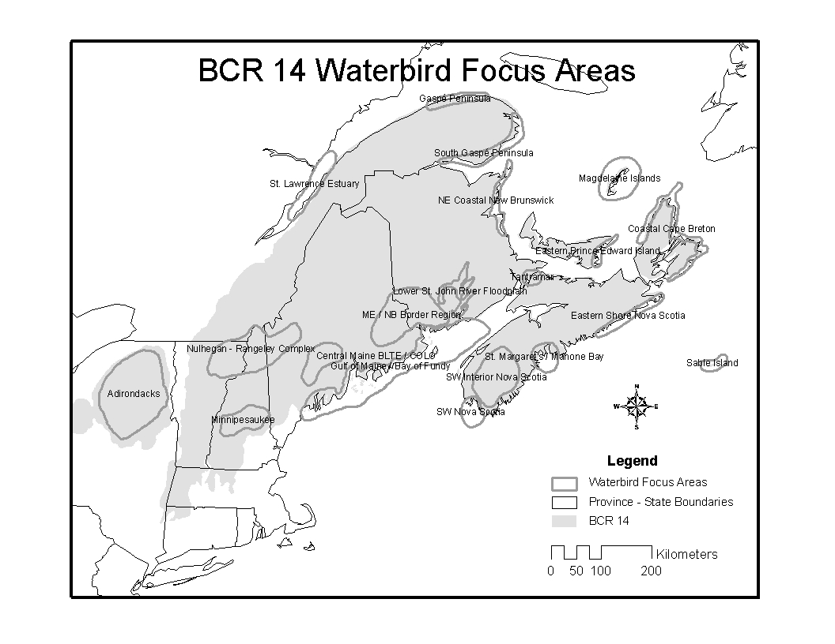
Fig. 9. Map of waterbird focus areas (outlined in dark gray) in BCR 14. See the following page for a list of focus areas by province/state and links to data sheets for all focus areas.
Waterbird Focus Areas in Quebec include: St. Lawrence Estuary, North Gaspé Penninsula, South Gaspé Penninsula, and Magdalen Islands.

Waterbird Focus Areas in New Brunswick include: Northeastern Coastal New Brunswick, Tantramar, Lower St. John River Flood Plain, Maine/New Brunswick Boarder Region, and Gulf of Maine/Bay of Fundy.

Waterbird Focus Areas in Prince Edward Island include: Eastern PEI (no data sheet) and Western PEI (not identified on map).

Waterbird Focus Areas in Nova Scotia include: Tantramar, Coastal Cape Breton, Eastern Shore Nova Scotia, St. Margaret’s/Mahone Bay, Southwest Interior Nova Scotia, Southwest Nova Scotia, and Sable Island.

Waterbird Focus Areas in Maine include: Maine/New Brunswick Boarder Region, Gulf of Maine/Bay of Fundy, Central Maine Black Turn/Common Loon Areas, and Nulhegan/Rangeley Complex.

Waterbird Focus Areas in New Hampshire and Vermont include: Nulhegan/Rangeley Complex and Winnipesaukee.

Waterbird Focus Areas in New York include: Adirondack Park.

Landbird Focus Areas
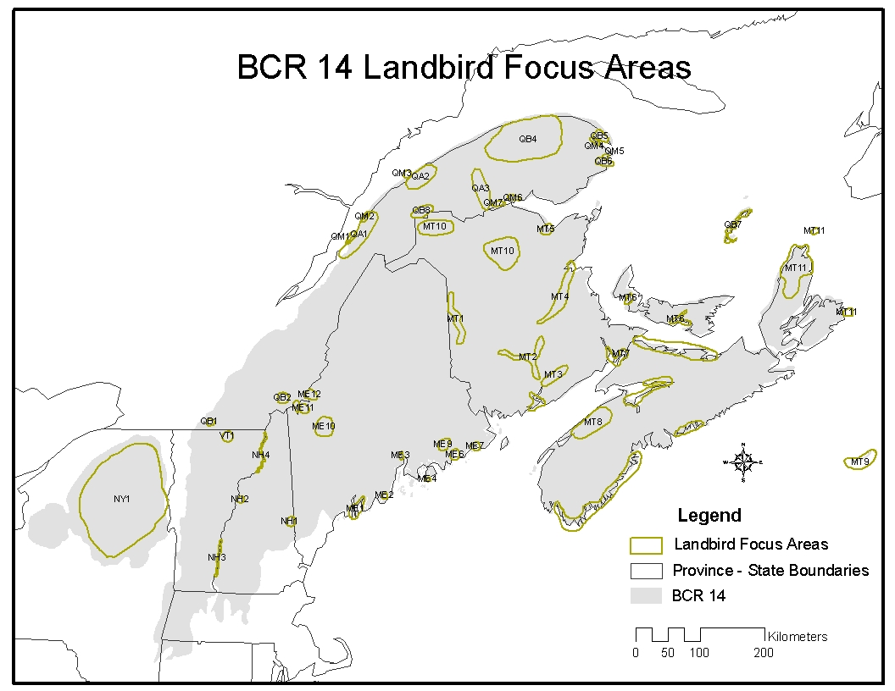
Fig. 10. Map of landbird focus areas (outlined in light green) in BCR 14. See the following page for a list of focus areas by sub-regions and links to more detailed maps and data sheets for these focus areas. Note that these focus areas are primarily for saltmarsh and grassland habitats, as well as some high elevation forest in Canada and Maine. Also see the Bicknell’s Thrush habitat map and the outputs from the bird-habitat modeling exercises for addition important landbird areas.

Landbird Focus Areas are presented in the following pages by groupings of provinces/states, with more detailed maps of each sub-region, followed by data sheets for the corresponding Focus Areas.

- Landbird focus areas in New York, Vermont, New Hampshire, Maine, and southern Quebec (click for map) include: Adirondack Park (NY1), Southern Lake Memphremagog (VT1), Ossipee Pine Barrens/Saco River Grassland Complex (NH1), Haverhill (NH2), Lower Connecticut River Valley (NH3), Upper Connecticut River Valley (NH4), Lower Kennebec River Marshes (ME1), Upper Sheepscot Marshes (ME1), Weskeag River Saltmarsh (ME2), Mendall Marsh (ME3), Bass Harbor Marsh (ME4), Downeast Saltmarsh Complex (ME5), Roque Bluffs (ME6), Downeast Blueberry Barrens (ME7), Saddleback-Sugarloaf Mtns. (ME8), Snow Mtn. (ME9), Kibby Mtn. (ME10), Mont Sutton (QB1), Mont Mégantic (QB2), and Monts Gosford and Marbre (QB3).
- Landbird focus areas in the Gaspe Peninsula and northern New Brunswick (click for map) include: Center of Gaspe peninsula (QB4), Forillon National Park (QB5), Percé vicinity and Île Bonaventure (QB6), New Brunswick-Québec border (QB8), St.-Pascal to St.-Andre (QM1), Cacouna to IsleVerte (QM2), Rimouski to Pointe-au-Père (QM3), Gaspé (QM4), Barachois de Malbaie (QM5), Rivière Nouvelle estuary (QM6), Pointe a la Croix (QM7), La Pocatière to Île Verte (QA1), Rimouski to Ste. Flavie (QA2), Valley of Matapédia (QA3), Upper Saint John River (MT1), Miramichi River (MT4), Bathurst (MT5), and North-central New Brunswick (MT10).
- Landbird focus areas in southern New Brunswick, Prince Edward Island, and Nova Scotia (click for map) include: Mid-Saint John River/Grand Lake (MT2), Sussex (MT3), Prince Edward Island (MT6), New Brunswick-Nova Scotia Border Region (MT7), Annapolis Valley (MT8), Sable Island (MT9), Northern Cape Breton Island/Scaterie Island/St. Paul Island (MT11), and Îles de la Madeline (QB7).

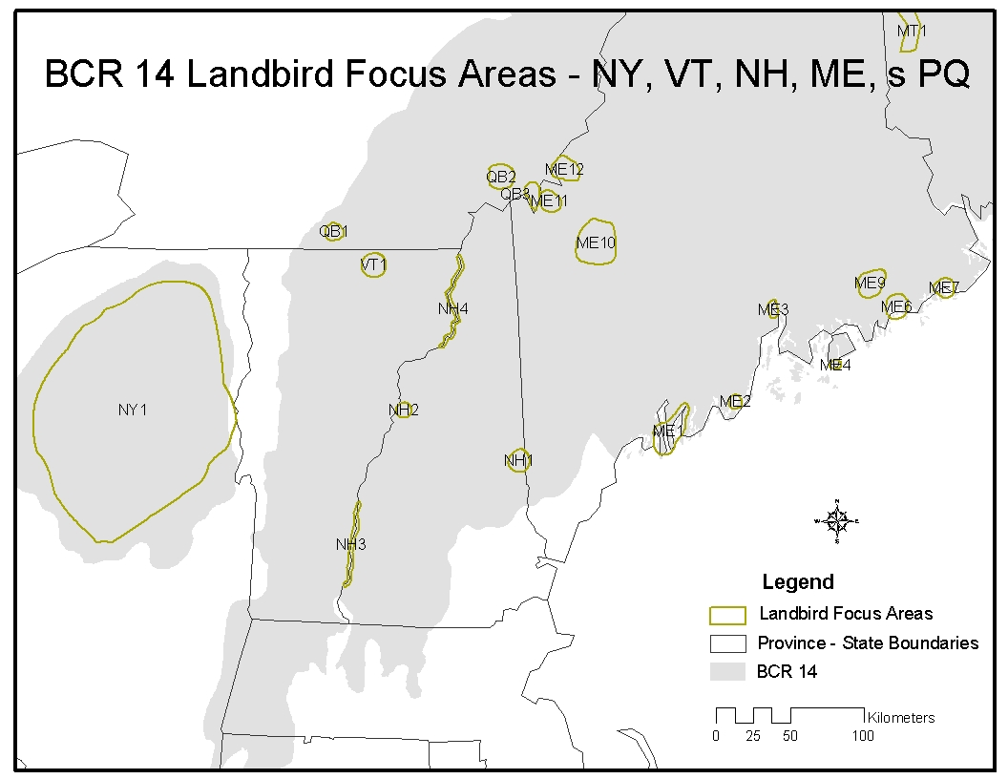
Fig. 11. Map of Landbird Focus Areas in New York, Vermont, New Hampshire, Maine, and southern Quebec: NY1, VT1, NH1, NH2, NH3, NH4, ME1-lower, ME1-upper, ME2, ME3, ME4, ME5, ME6, ME7, ME8, ME9, ME10, QB1, QB2, QB3.

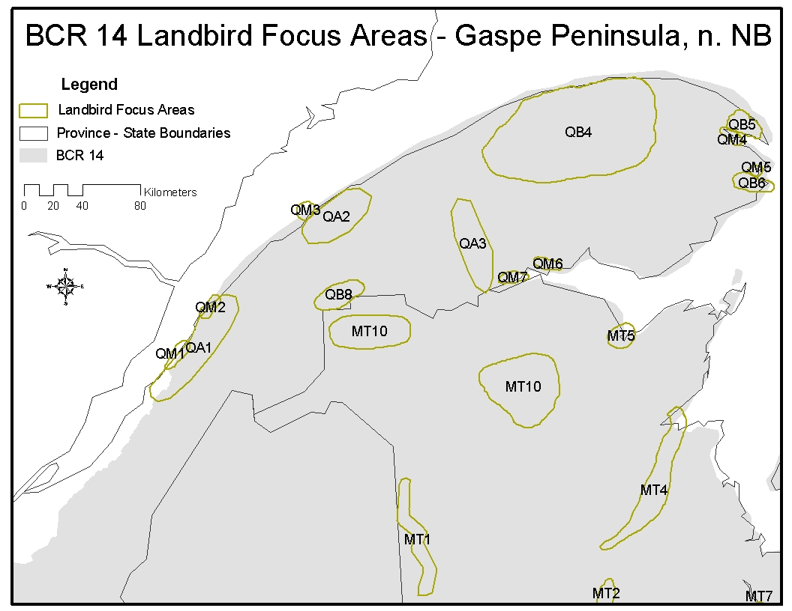

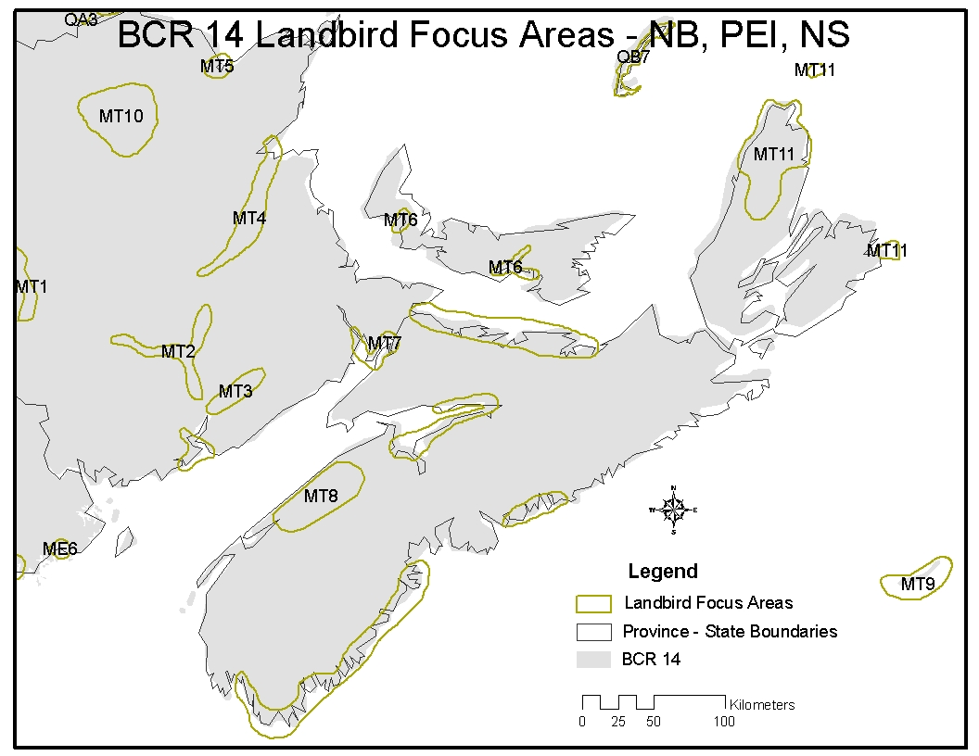

Waterfowl Focus Areas
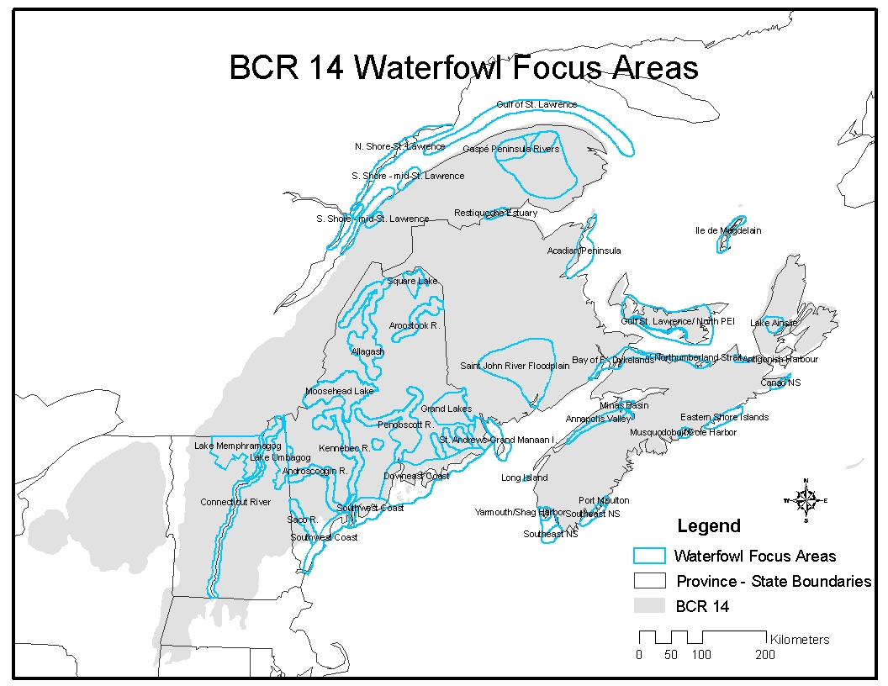
Fig.15. Map of waterfowl focus areas (outlined in light blue) in BCR 14. See the following page for more information on where to find descriptions of these focus areas.
Waterfowl Focus Areas are presented in the following pages by groupings of provinces/states, with more detailed maps of each sub-region, followed by data sheets for the corresponding Focus Areas:

- Waterfowl focus areas in Nova Scotia, Prince Edward Island, southern New Brunswick (click for map) include: Minas Basin, Annapolis Valley, Digby-Brien Island, Yarmouth/Shag Harbor, Southeast Nova Scotia, Port Moulton (no data sheet), Musquodobit/Cole Harbor/Lawrencetown, Eastern Shore Islands Management Unit, Canso Nova Scotia, Lake Ainslie, Antigonish Harbor, Northumberland Strait-Nova Scotia, Northumberland Strait-PEI, Gulf of St. Lawrence/North PEI, Bay of Fundy Dykelands, St. John River Floodplain, and St. Andrews to Grand Manan Island (no data sheet).
- Waterfowl focus areas in Quebec and northern New Brunswick (click for map) include: North Shore of St. Lawrence Estuary, South Shore of mid-St. Lawrence Estuary, Gulf of St. Lawrence (no data sheet), Gaspé Penninsula Rivers, Restiquoche Estuary, Magdalen Islands, and Tabusintac/Acadian Penninsula.
- Waterfowl focus areas in Maine, New Hampshire, and Vermont (click for map) include: Downeast Coast, Lower Merrymeeting Bay, Southwest Coast, Cobscook Bay, Narraguagus River, Aroostook River, Machais River, Saco River, Allagash/St. John Rivers, Flagstaff Lake/Dead River/Kennebec River, Androscoggin River, Piscataquis/Penobscott Rivers, Sebasticook Lake, Square Lake, Moosehead Lake, Grand Lakes/St. Croix River, Lake Umbagog, Connecticut River, and Lake Memphramagog. Descriptions of these waterfowl focus areas have been completed by the Atlantic Coast Joint Venture and are available on the ACJV website.
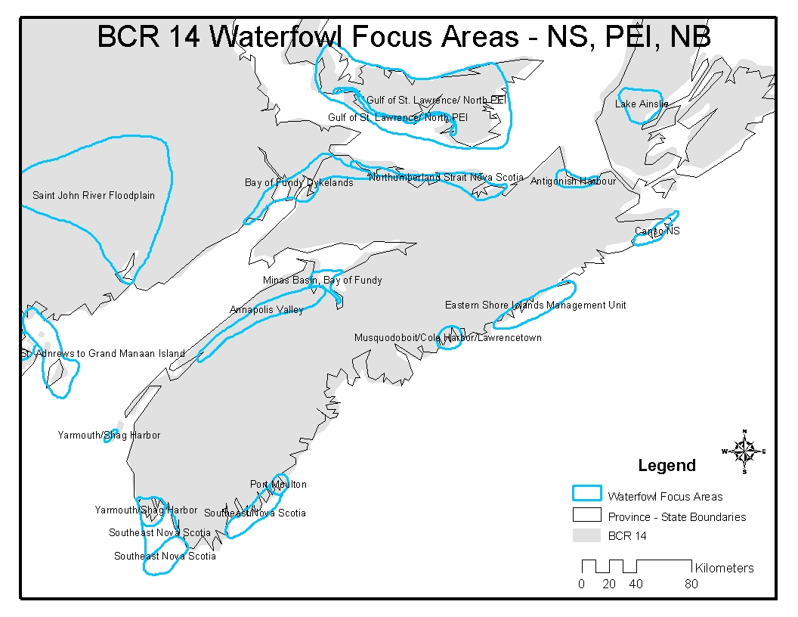
Fig. 16. Map of Waterfowl Focus Areas in Nova Scotia, Prince Edward Island, and southern New Brunswick.
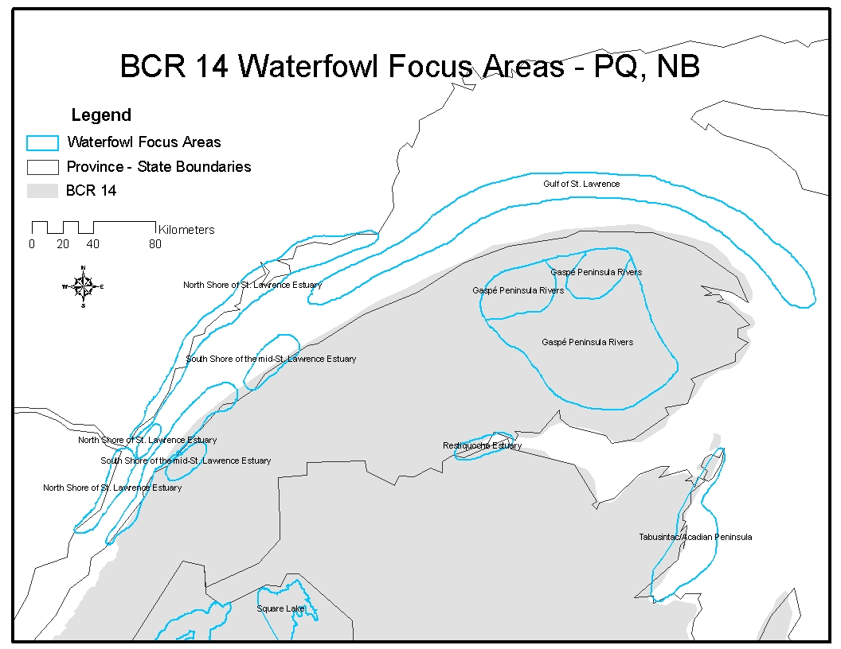
Fig. 17. Map of Waterfowl Focus Areas in Quebec and northern New Brunswick.
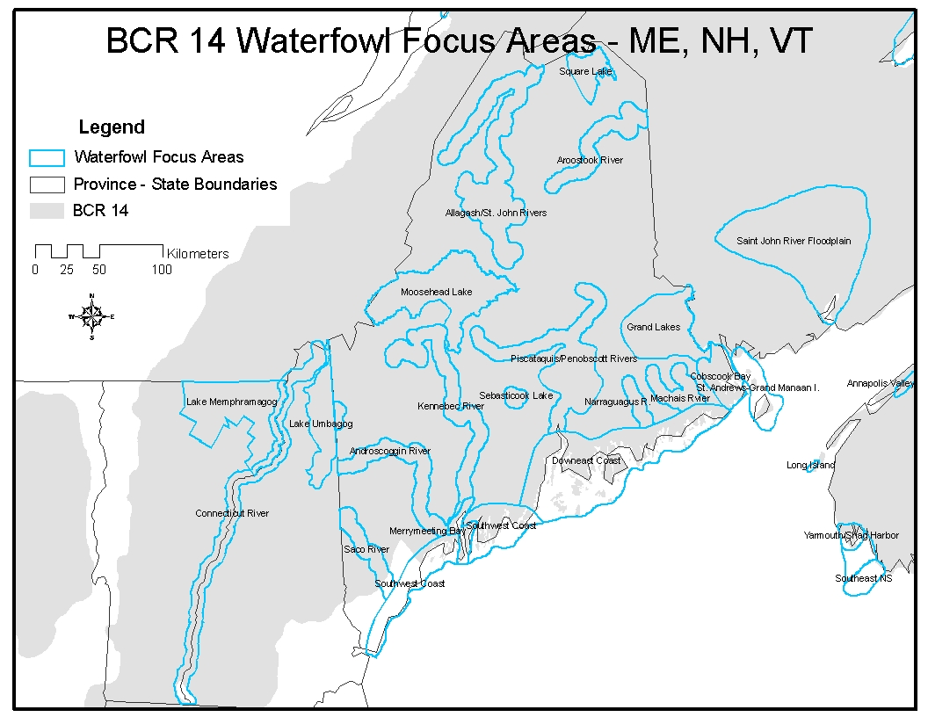
Fig. 18. Map of Waterfowl Focus Areas in Maine, New Hampshire, and Vermont. Descriptions of these waterfowl focus areas can be found on the “Publications” page of the Atlantic Coast Joint Venture website.
Shorebird Focus Areas
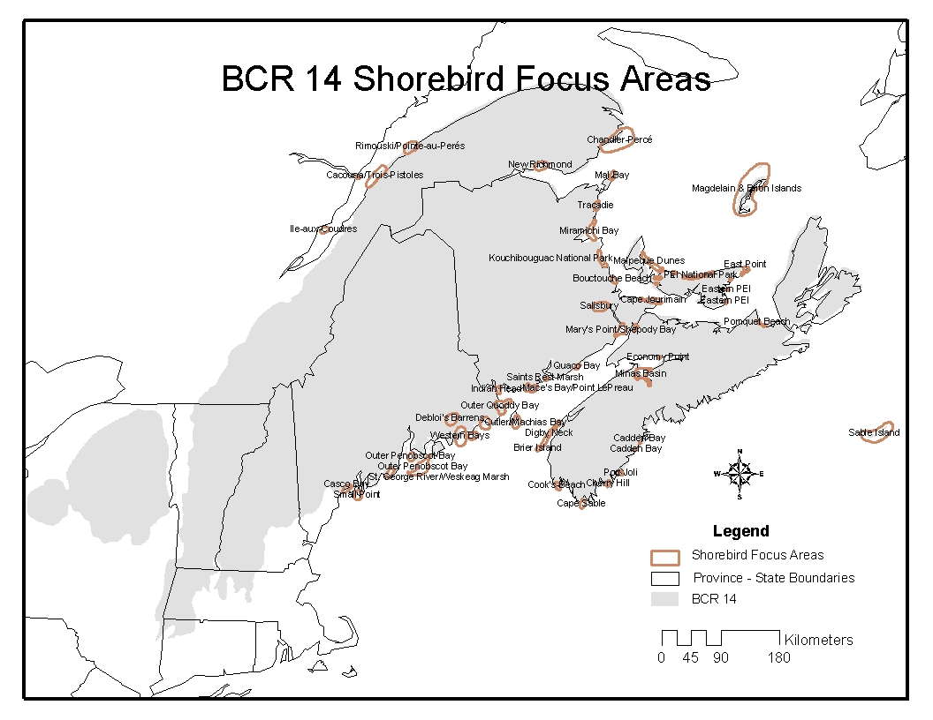
Fig. 20. Map of shorebird focus areas (outlined in brown) in BCR 14. See the following pages for more detailed maps of focus areas around the Bay of Fundy and Gulf of St. Lawrence and a list of focus areas by province/state.
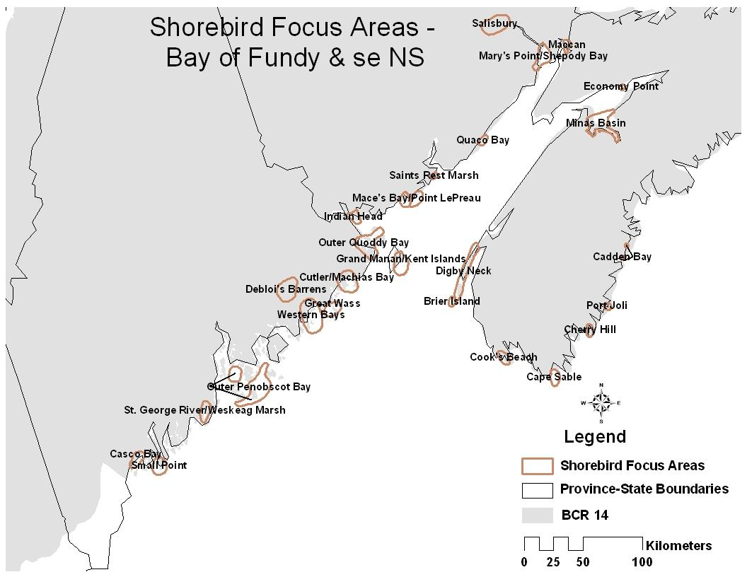
Fig. 21. Shorebird focus areas around the Bay of Fundy and southeastern New Brunswick.

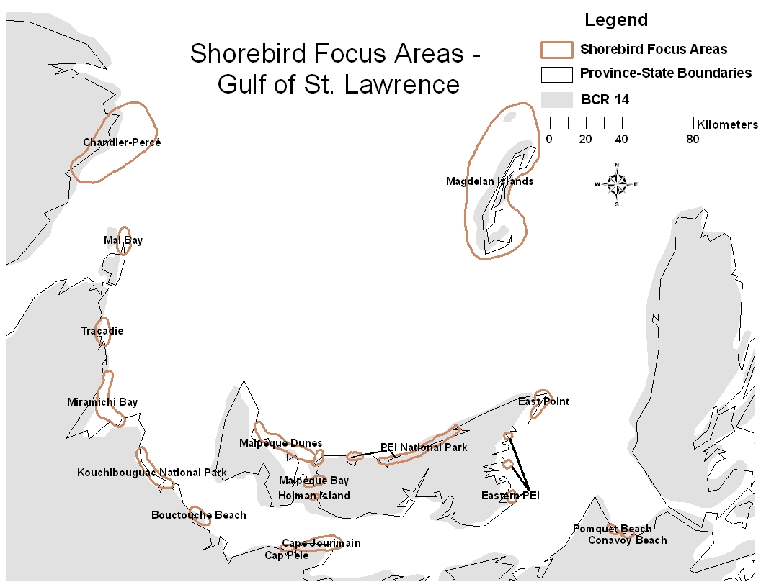
Fig. 22. Shorebird focus areas around the Gulf of St. Lawrence

